**Name: Arnav Ranjan**

**Roll Number: R171218029**

**SAP ID: 500067731**

**Lab: 8**

**Uploading artifacts on Nexus Server using command line**

**Steps**

**1.** Start nexus using this command “nexus.exe /run”.

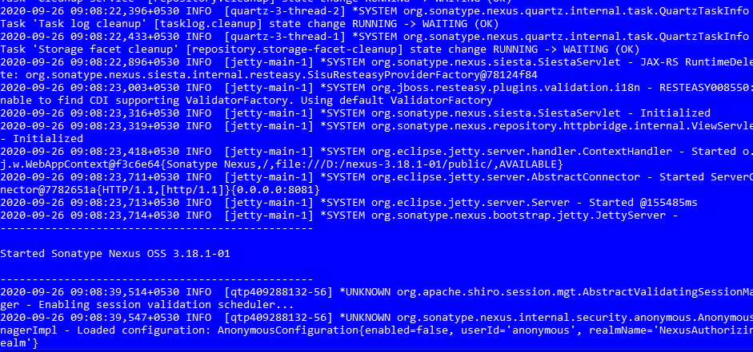

**2.** Open browser and type <http://localhost:8081>

**3.** Login to your nexus account.

**4.** Create a repository

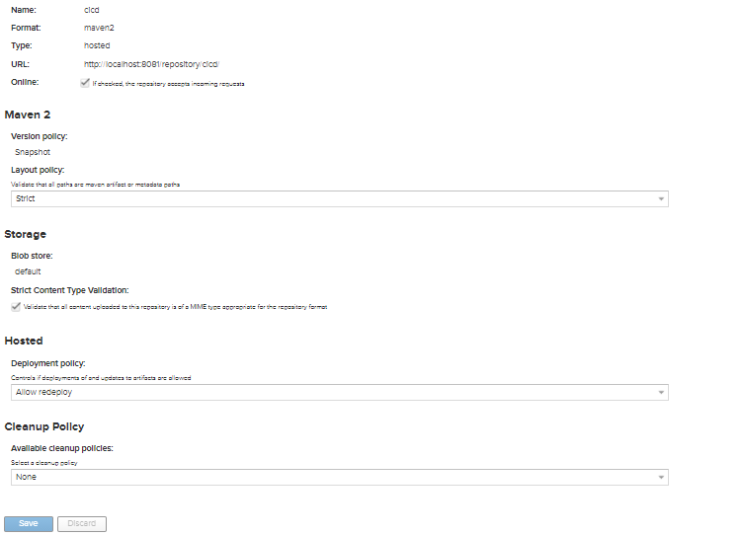

**5.** Change your pom.xml file where your apache maven is located

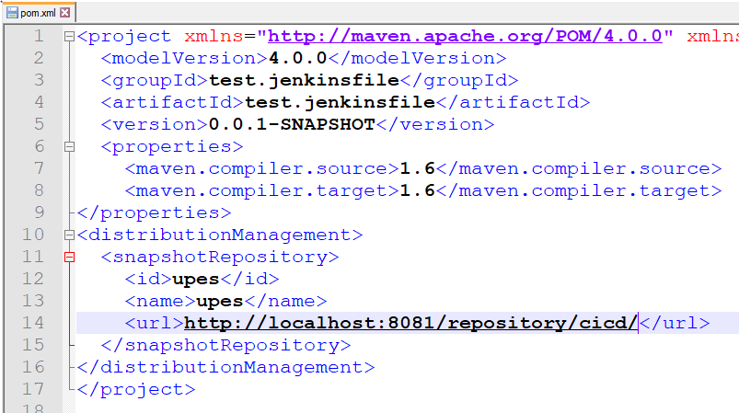

**6.** Run another cmd and go to your project and then run command “mvn clean”

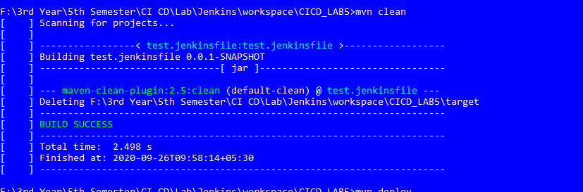

**7.** After that run command “mvn deploy”

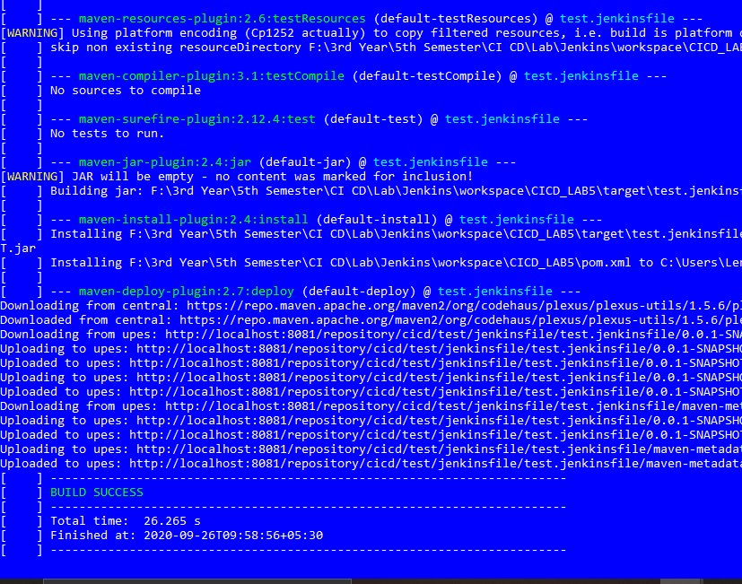

**8.** Go back to nexus

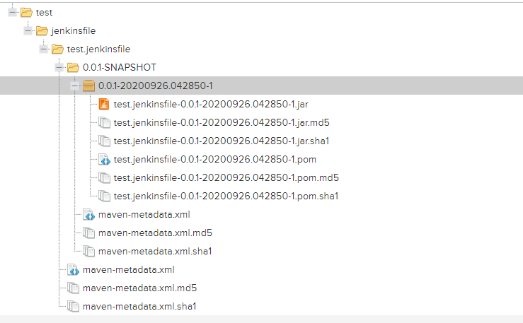

**9.**

